Project: Instructions

Assessment Resources:
Marking key available for lecturer via Blackboard.
Students may refer to the lecture material (GitHub and Blackboard) in formulating their answers.
Refer to https://github.com/NM-TAFE/ipriot-nms-org-template/tree/main/org for relevant code style guides, git usage, and other organizational policies and procedures related to the scenario

Assessment Instructions:
Students must complete every section. Answer succinctly using full sentences. At most three paragraphs are expected per answer.
All answers must be at the student’s own words – copying generated code or answers from ChatGPT or other AI tools is strictly prohibited.
Please ensure that all instructions are followed carefully, and submissions are well-organized, clearly labelled, and accompanied by any necessary explanations or justifications.

Objectives
By completing this task, you will demonstrate the following competencies as outlined in ICTPRG430:
- Modularity: Implementing the program using a modular approach.
- Data Structures: Utilizing arrays of primitive data types within a class.
- File Operations: Reading from and writing to a text file.
- Class Design: Developing multiple classes in response to a specification
- Object Aggregation: Employing user-defined object aggregation within a class.
- Polymorphism: Implementing polymorphism to enhance code extensibility.
- Debugging: Utilizing a debugging tool to troubleshoot your code.
- Code and Documentation Conventions: Applying specified coding and documentation standards.
- Unit Testing: Conducting and documenting unit tests.
As part of this assessment, you will demonstrate competencies in using a version control system, as outlined in ICTICT449. You will plan, install, create, and manage a repository to control versions of your code for the system you implement to complete the scenario. You must follow the commit and branching standards outlined in the NMS onboarding guide.

Scenario
The City of Moondalup is progressively embracing smart city initiatives to enhance urban living, improve efficiency in city services, and promote sustainable practices. As part of this initiative, the city council is eager to transition to a smart parking solution to optimize carpark usage, reduce traffic congestion, and enhance the overall parking experience for residents and visitors.
You have been contracted to create a prototype solution that uses sensors and displays to provide timely information about available parking bays as well as relevant information about weather and other community messages.
The city’s Chief Technology Officer (CTO), has outlined the following requirements:
- The system must accurately track and show availability of bays in real-time.
- The displays must be able to show ambient temperature and arbitrary announcements.
- The system must store the scanned license plates of cars.
- The system must work in uncontrolled car parks.
- The display must be updated promptly as cars enter or exit.
- The system should be robust, easy to maintain, and scalable for future enhancements.
- The application must follow best coding practices and include unit tests.
- You must use Git and GitHub for version management.

Coding requirements
To meet the specifications of the project, you must do the following:
- Create at least three classes
- At least one class must include three or more parameters
- At least one class must aggregate another class
- At least one class must include a list (array) of primitive data types
- You should demonstrate an example of polymorphism
- Include at least two unit tests
- Read and write configuration from a file
- Allow carpark to be constructed either from a direct call or via the configuration file (two options for object construction)
- Create a main.py demonstrating the core interaction between instances of your classes
- Use PEP8 throughout your code and docstrings for major functions within your code
- Record and provide evidence of debugging
- Apply at least three different documentation conventions (readme, docstring, comments)

Version control requirements
- Follow the guidelines in the NMS Onboarding guide
- Create a new repository and configure it with a README, .gitignore, and other essential setup files.
- Initialize your local repository and link it to a remote repository on GitHub.
- Create a branch with your work
- Make initial commits with the basic structure of your Carpark system.
- As you develop the system, commit your changes each time you reach a significant milestone or complete a task.
- Make at least three commits to demonstrate the evolution of your project (please note, if you use the project guide to develop your project, you will be asked to make additional commits as proof-of-work)
- Ensure that any down time or service interruptions that may result from your changes are clearly communicated
- Manage any changes or improvements by committing to the repository with clear, descriptive commit messages.
- Finalize your submission by documenting the final outcome by:
  - (a) pushing your changes to your branch
  - (b) creating a descriptive PR and
  - (c) merging the PR with main
  - (d) pull from the remote main to the local main
  - (e) delete the branch both locally and remotely
  - (f) add an annotated tag and push to git
  - (g) add release documentation

Key references
Organizational programming style guide: https://github.com/NM-TAFE/ipriot-nms-org-template/blob/main/org/code-style-guide.md
Commit message and branching guideline: https://github.com/NM-TAFE/ipriot-nms-org-template/blob/main/org/git-onboarding-guide.md

Questions
- What is an example of polymorphism in your code? Identify the file and line number and justify your answer. In what way did this example help achieve code extensibility?

In sensor.py (line 19), the update_car_park() method demonstrates polymorphism. Polymorphism refers to the ability of subclasses to implement behaviours that differ from one another while sharing a common interface. In this case, update_car_park() is declared as an abstract method, allowing the subclasses EntrySensor and ExitSensor (located in entry_sensor.py, line 4, and exit_sensor.py, line 6) to override the method and provide their own specific implementations. This design enables each sensor type to exhibit distinct behaviour while conforming to the same method signature.

- What is an example of aggregation in your code? Identify the file and line number and justify your answer
The code in car_park.py demonstrates aggregation through the way Display objects are managed by the CarPark class. This is evident in several locations: the parameter declaration on line 14 (displays: list[Display] | None = None), the initialisation of the displays list on lines 26–28, and the addition of Display objects via self.displays.append(hardware) on line 88.
This is aggregation because Display objects are created outside the CarPark and registered via register(), meaning they have an independent lifecycle. If the CarPark is destroyed, the displays can continue to exist, demonstrating a “has-a” relationship rather than composition.
- Outline at least one specific instance where you performed debugging.
Ensure the assessor can identify a concrete problem that affected you.
Generic answers will not be accepted.
What was the issue?
While running my tests, I encountered an exception: "Can't instantiate abstract class Sensor without an implementation for abstract method 'update_car_park'". This stopped the program because the abstract Sensor class was being instantiated directly instead of using EntrySensor or ExitSensor.
How did you identify the problem?
I read the traceback, which pointed to the exact line where the abstract class was being instantiated. I then inspected the test code and confirmed that I had accidentally created a Sensor() instead of one of its subclasses.
What steps did you take to resolve the problem?
I updated the test so it instantiated EntrySensor and ExitSensor instead of the abstract Sensor class. I also checked the constructor calls throughout the code to ensure no other part instantiated the abstract class directly.
Would any refactoring make similar problems easier to debug (or avoid) in the future?
Yes. Marking Sensor as an abstract base class in a separate module and improving type hints would make it clearer that it should never be instantiated. Adding unit tests specifically for subclass behaviour would also prevent accidental use of the abstract class.

- Attach a screenshot of your GitHub repository that captures part of your development process:
- The screenshot must show the commit graph after an atomic commit that isn’t the first or last commit
- The commit message shown must be meaningful and follow the commit guidelines
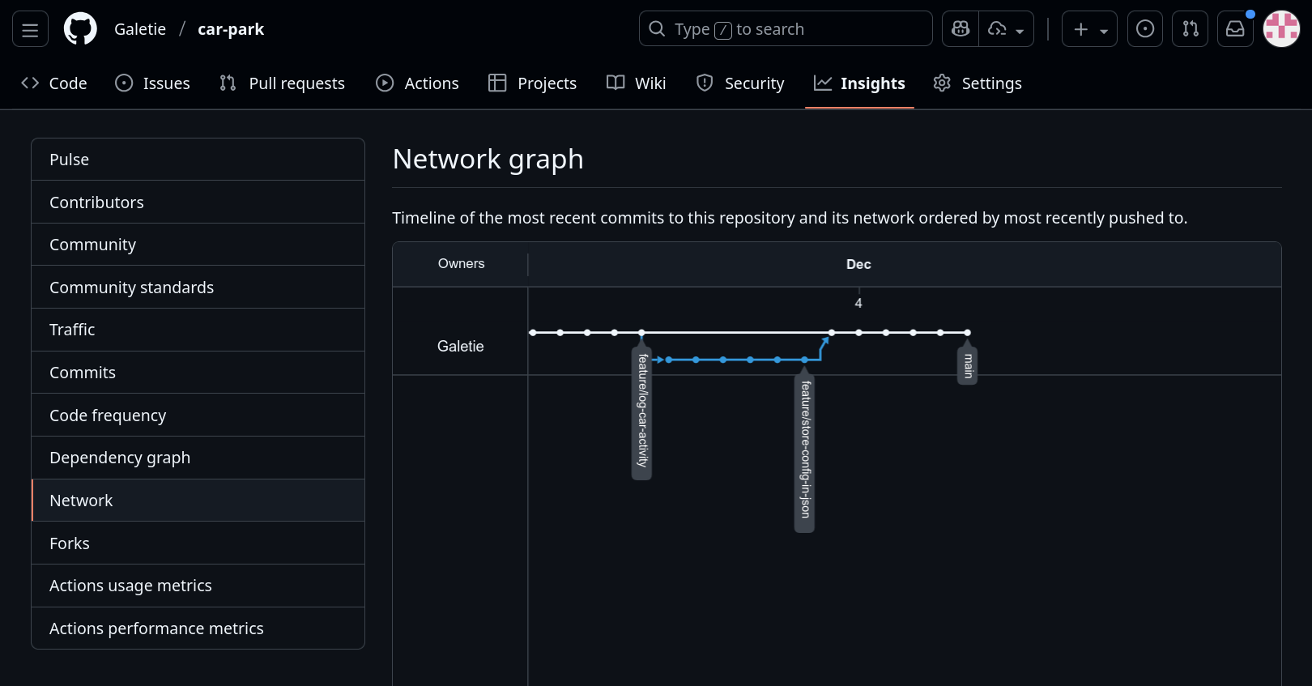
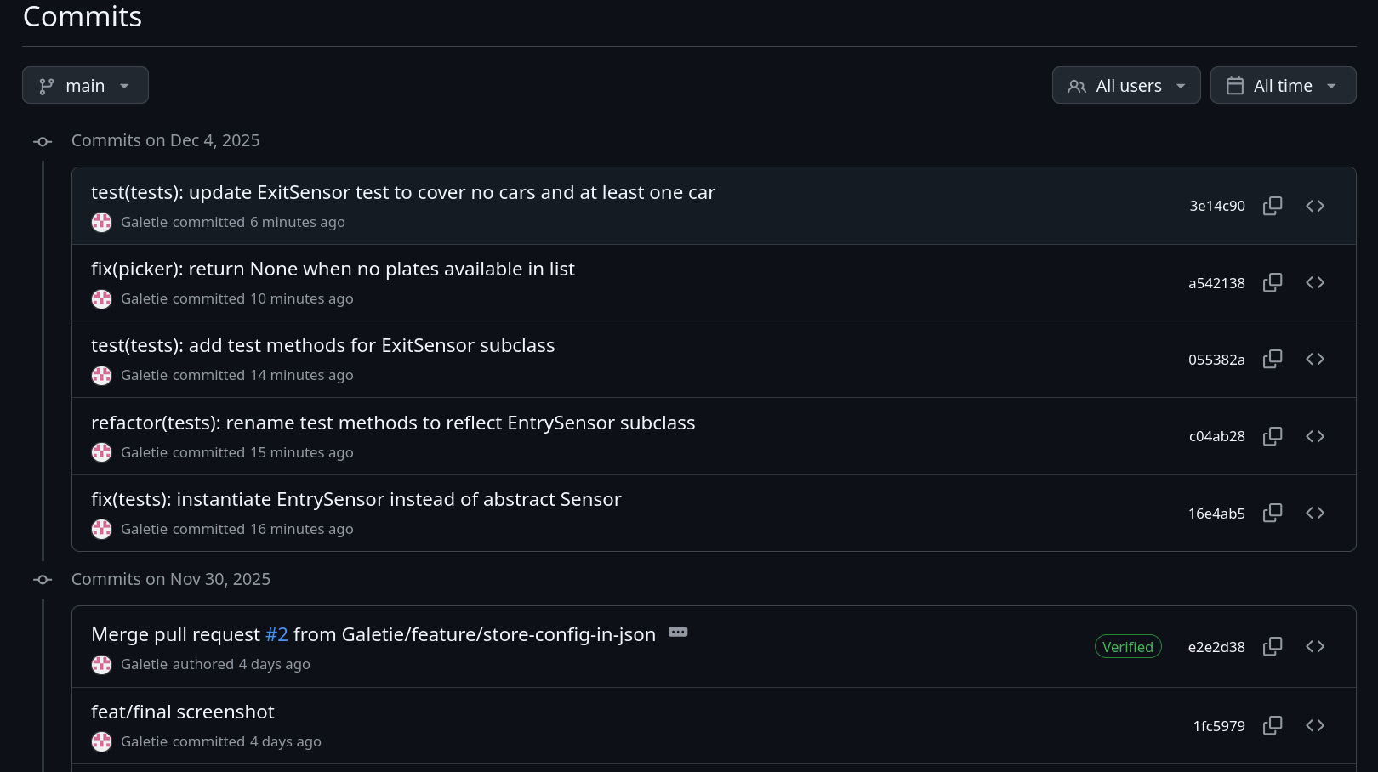
- Provide a screenshot of the PR or release notes you used to document the final outcome of the project.
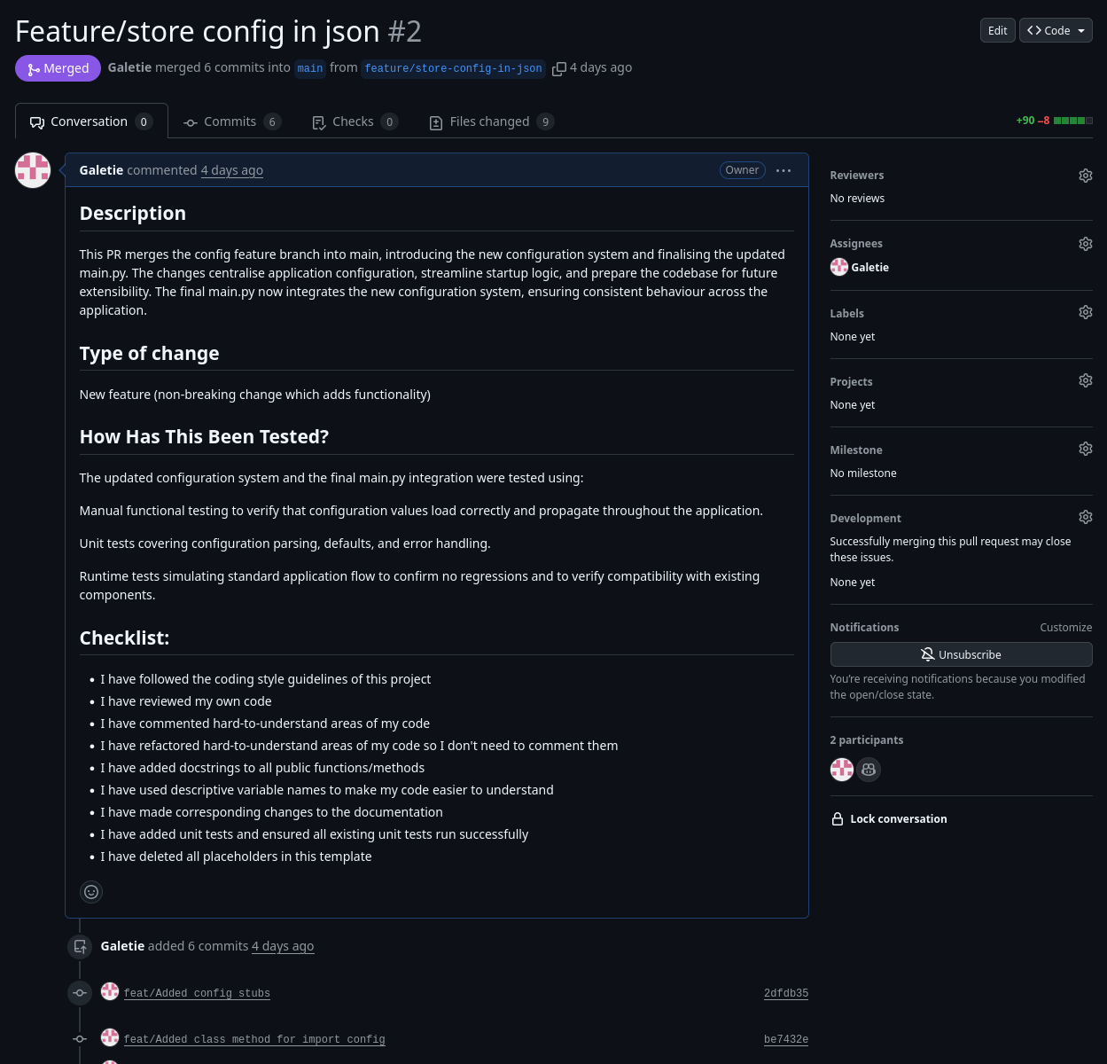

Coding Checklist
- Complete the following checklist and reference examples of each of the constructs, where file name, is the name of a submitted file, line number, is the line number (or range) for your example.

 | Item | Description | File Name | Line Number/First Line
 | Class you defined (1) | CarPark | car_park.py | Line 8
 | Class you defined (2) | Display | Display.py | Line 1
 | Class you defined (3) | Sensor | Sensor.py | Line 5
 | Reading and Writing from file | Save car park configuration (location, capacity, log file paths) to a JSON file for persistence and later retrieval. | car_park.py | Read file: Line 59  Write File: Line 47
 | Two options for object construction | __init__() - Standard constructor (line 8)  from_config() - Alternative constructor using class method (line 59) | car_park.py | Line 8 and 59
 | Class with an array (list or tuple) of primitive (built-in) types | CarPark – Has a list of strings (self.plates) | car_park.py | Line 13
 | Unit test (1) | Test: test_add_car (in TestCarPark)  Testing: Adding a car updates the plates list and decrements available bays  Arrange: Set up CarPark in setUp() with capacity 100  Act: Call self.car_park.add_car("FAKE-001")  Assert: Verify plates list contains "FAKE-001" and available_bays equals 99 | test_car_park.py | Line 22
 | Unit test (2) | Test: test_detect_vehicle_exit (in TestSensor)  Testing: Exit sensor correctly detects vehicle and removes it from car park  Arrange: Create CarPark, EntrySensor, and ExitSensor; add a car via entry sensor  Act: Call self.exit_sensor.detect_vehicle()  Assert: Verifies exception raised when no cars present, then successful detection after adding car | test_sensor.py | Line 25
 | Main.py | Creates instances of all classes:  CarPark - created with location, capacity, log file  Display - created and registered with car park  EntrySensor - created and linked to car park  ExitSensor - created and linked to car park  Demonstrates functionality: Writes config to file  Reads config from file to recreate CarPark Simulates 10 cars entering via entry sensor  Simulates 2 cars exiting via exit sensor | Main.py | NA

Version Control Checklist

- Complete the following checklist and reference specific commits if applicable

 | Item | Description/Why | Commit Message | Commit ID
 | Included .git with submission | NA | NA | NA
 | Commit (1) | Added alternative constructor to load CarPark configuration from JSON file | feat/Added class method for import config  Should have been:  feat(car-park): add class method for import config | be7432e
 | Commit (2) | Implemented logging functionality to track car entry/exit activities with timestamps | feat/Added logging to the carpark class  Should have been:  feat(car-park): add logging to CarPark class | 3a0290c
 | Commit (3) | Created unit test to verify register method correctly handles Sensor and Display objects | feat/implemented register test to CarPark test cases  Should have been:  test(car-park): implement register test to CarPark test cases | fcd314f
 | Pushed all work in branch to GitHub | NA | NA | NA
 | Pulled work from remote to local main after PR | NA | NA | e2e2d38
 | Delete local branch | feat/basic-car-park-system  feature/log-car-activity  feature/store-config-in-json | NA | NA

Submission
Your final submission should include:
- Your .git/ must be included with your zip file.
- Your .gitignore file should exclude any files that are not required for marking
- Do not include venv/ in your submission.
- This worksheet, completed with your documentation and optionally the completed carpark project guide (only required for evidencing authenticity).

Assessment Criteria
You will be assessed on:
- The correct implementation of OOP concepts.
- Code functionality and adherence to the provided specifications.
- Use of object-oriented constructs as specified in the Coding requirements
- Quality and clarity of code documentation.
- Successful execution and documentation of unit tests.
- Appropriate commit history and steps as per the core instructions.

